Supplementary Information for ''A Systematic Method for Fouling Morphology Analysis''
Yipeng Yao ^{1, 2, 3,} *, Zhiqiang Han ^{2, 3,} **, Liping Luo ², Hai Du ², Wei Tian ², Xueshun Wu ², Zinong Zuo ², Marie-Eve Duprez ¹, Guy De Weireld ¹
1. Thermodynamics and Mathematical Physics Unit, Faculty of Engineering, University of Mons, Place du Parc 20, Mons, 7000, Belgium
2. Key Laboratory of Fluid and Power Machinery, Ministry of Education, Xihua University, Chengdu 610039, China
3. Engineering Research Center of Ministry of Education for Intelligent Air-Ground Fusion Vehicles and Control, Xihua University, Chengdu 610039, China
* Corresponding author:
E-mail address: yipeng.yao@umons.ac.be (Yipeng Yao).
** Corresponding author:
E-mail address: hanzq@mail.xhu.edu.cn (Zhiqiang Han).

Table S1. The meta information of characterisation for EGR cooler fouling morphology.
Scale | Object | Category | Typical description words | Characterisation techniques
Macroscopic | Fouling layer | Size | Thickness: 68.32 - 130.6 um [1], 149 - 274 um [2], 0 - 250 um [3], 26 – 160 um [4] | Visual inspection, optical microscope,  Neutron tomography,  Infrared thermography
Macroscopic | Fouling layer | Color | Black[5-9], yellow[10, 11], brown[9, 11, 12], gold [13], grey [14-16], white [17]
Macroscopic | Fouling layer | Shape | Cross-section: The top surface of the fouling is roughly parallel to the wall [18, 19], and the top surface fluctuates and undulates regularly with the wall [3, 4, 20]
Macroscopic | Fouling layer | Glossiness | Shiny [20]，high-reflectivity [20, 21], glossy [20, 22], matte-varnish [5, 9, 10, 23, 24]
Macroscopic | Fouling layer | Wetness | Dry and wet [5, 6, 20, 25-29], oily [5, 25], like parched soil [30]
Macroscopic | Fouling layer | Compactness | Powdery [5, 6, 20, 28, 29, 31], Powder-Lacquer [21, 28, 32, 33], dense [3, 19-21, 29, 30, 32-38], porous [3, 7, 8, 20, 34, 35, 39, 40], porosity [19, 30, 32, 36, 37], cavity structure [33], flocculent [1], loose [39] | Optical microscope, digital microscopy, surface profiler, scanning electron microscope
Macroscopic | Fouling layer | Roughness | Rough [14, 22, 36-38, 41-44], smooth [14, 28, 37, 38, 42, 44-47]；dune-like [48], area ratio [47]
Macroscopic | Fouling layer | Fragmentation | Crack [3, 8, 20, 22, 28, 49, 50], groove [20, 44], notch [20, 22, 44, 51], crusher [50], scratches [51], speckles [40], corrode [20, 48, 50]
Mesoscopic | Fouling layering | Size | Thickness: 0 – 10 um for hard layer, 0-1.5 mm for powdery layer [33]
Mesoscopic | Fouling layering | Number of layers | Two layers [19, 22, 41, 52]
Mesoscopic | Fouling layering | Compactness | Top layer: Dendritic [38, 41, 46], fine nanometer structure [53], racemose [33];  Bottom layer: Dense [22, 41, 52]
Mesoscopic | Fouling layering | Connection way | Columnar [41]
Mesoscopic | Clusters/aggregates / large particles | Size | 1.0 - 639 um [11]
Mesoscopic | Clusters/aggregates / large particles | Shape | Debris [22, 39, 54], fragment [22], flaky [35, 50], rounded agglomerates [22]
Mesoscopic | Clusters/aggregates / large particles | Connection way | Mechanical interlock [34, 38, 41], bridge [20]
Microscopic | Particle matter | Size | Around 200 – 400 nm* [44, 55] | Scanning electron microscope
Microscopic | Particle matter | Shape | Spherical shape [56, 57], irregular shape [56], | Scanning electron microscope
Microscopic | Particle matter | Connection way | String of pearls [20, 22] | Scanning electron microscope
Nanoscopic | Primary particle | Size | Around 50 nm* [56, 57] | Transmission electron microscope
Nanoscopic | Primary particle | Shape | Crystalline structure [58], amorphous (turbostratic) structure [57] | Transmission electron microscope
Nanoscopic | Primary particle | Orderliness | Ordered [56, 57], lower organization [56, 58], disordered [57], randomized [44] | Transmission electron microscope
Nanoscopic | Primary particle | Connection way | Chain like structure [56] | Transmission electron microscope
*: Estimated roughly from the scale given in the original article.

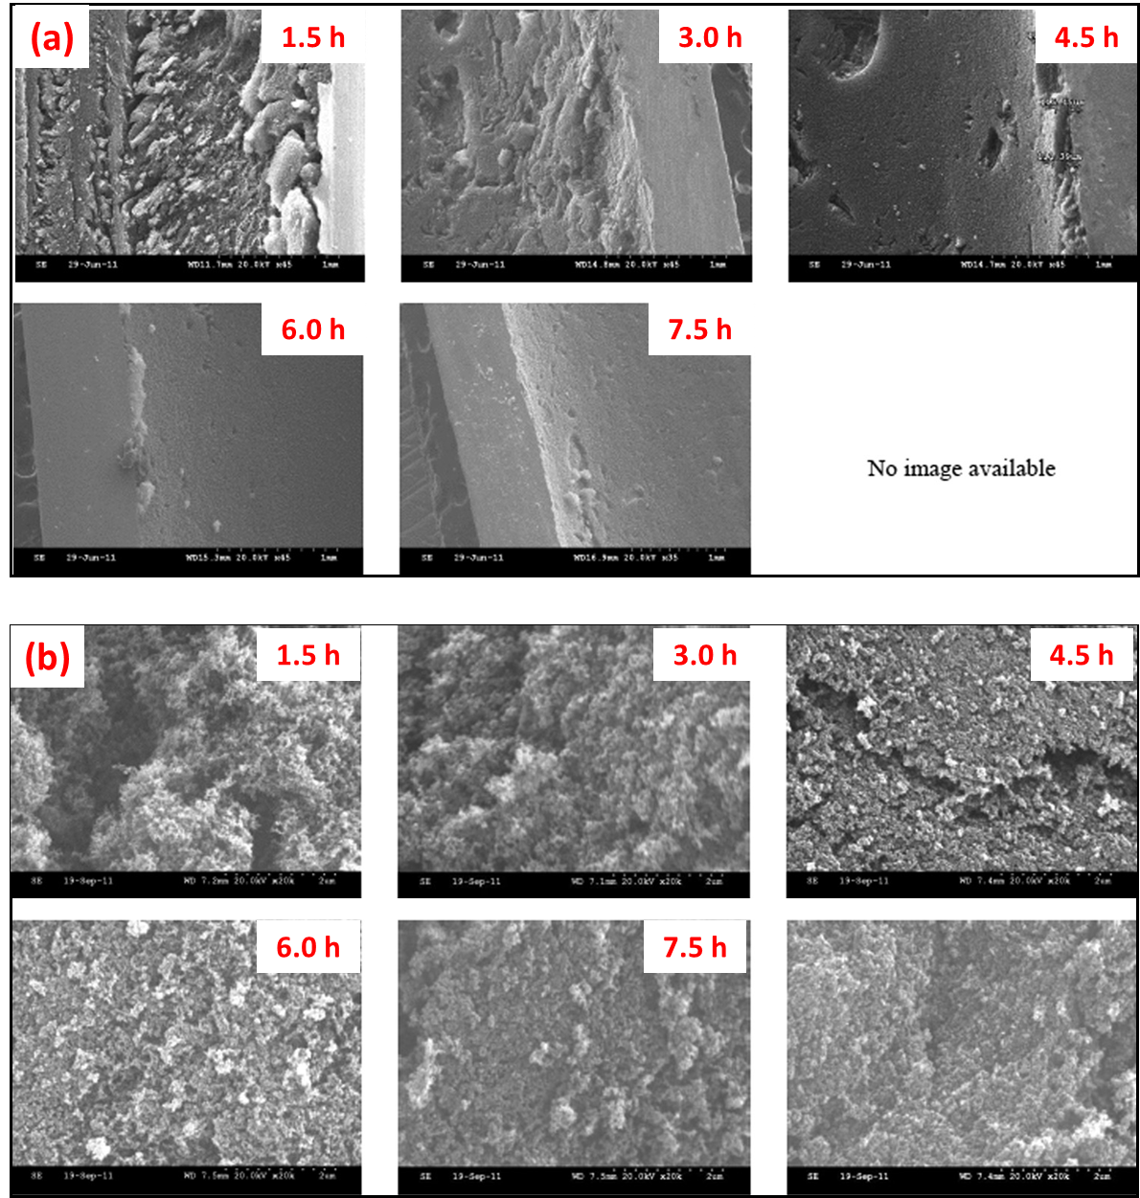
Figure S1. Variation of fouling microstructure as a function of time. (a) low magnification, (b) high magnification [37]

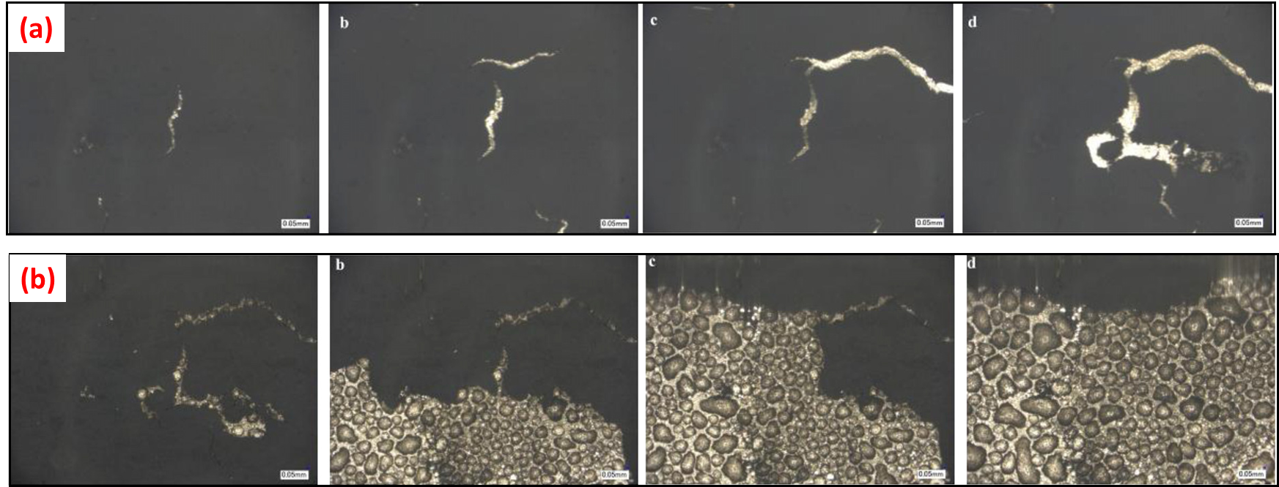
Figure S2. Cracks in fouling. Flow direction from left to right. (a) five minute interval between successive images in 42°C, (b) one minute interval between successive images in 20°C [40]
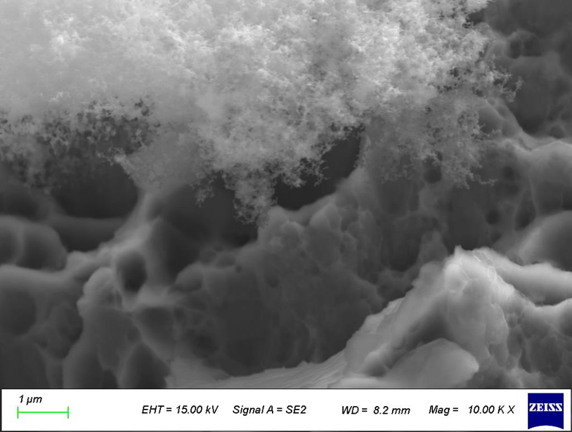
Figure S3. Fouling interlayer columnar connections. (Measured and provided by our team)
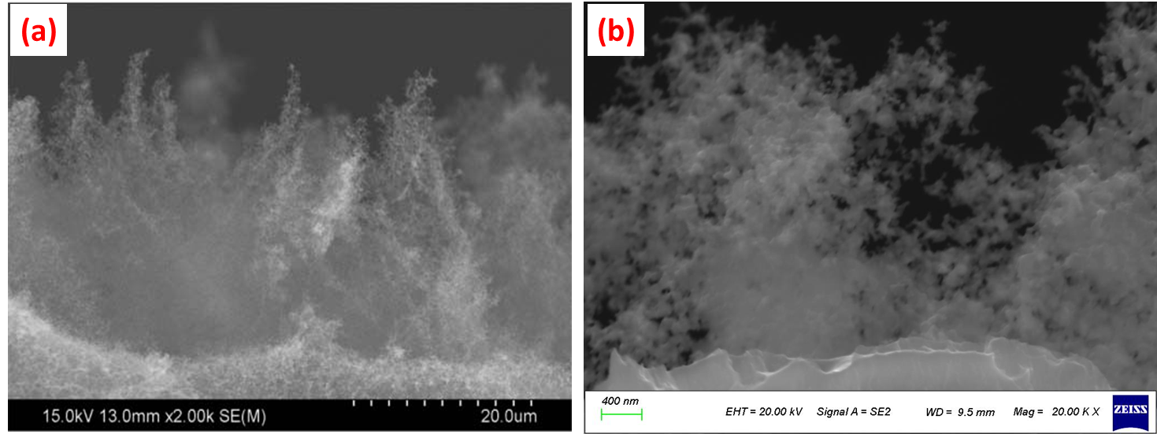
Figure S4. Dendritic form of fouling in the gas-fouling interface. (a)2 KX [41], (b) 20 KX image from our lab.
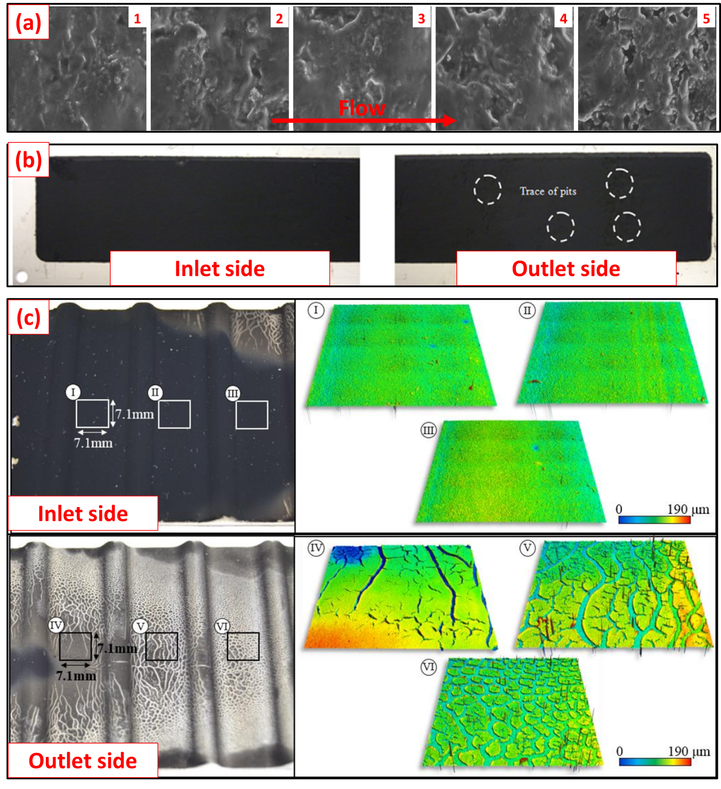
Figure S5. Fouling roughness distribution along the airflow direction. (a) Tian et al. [59], (b) Al-Janabi and Malayeri [51], (c) Paz et al. [28].

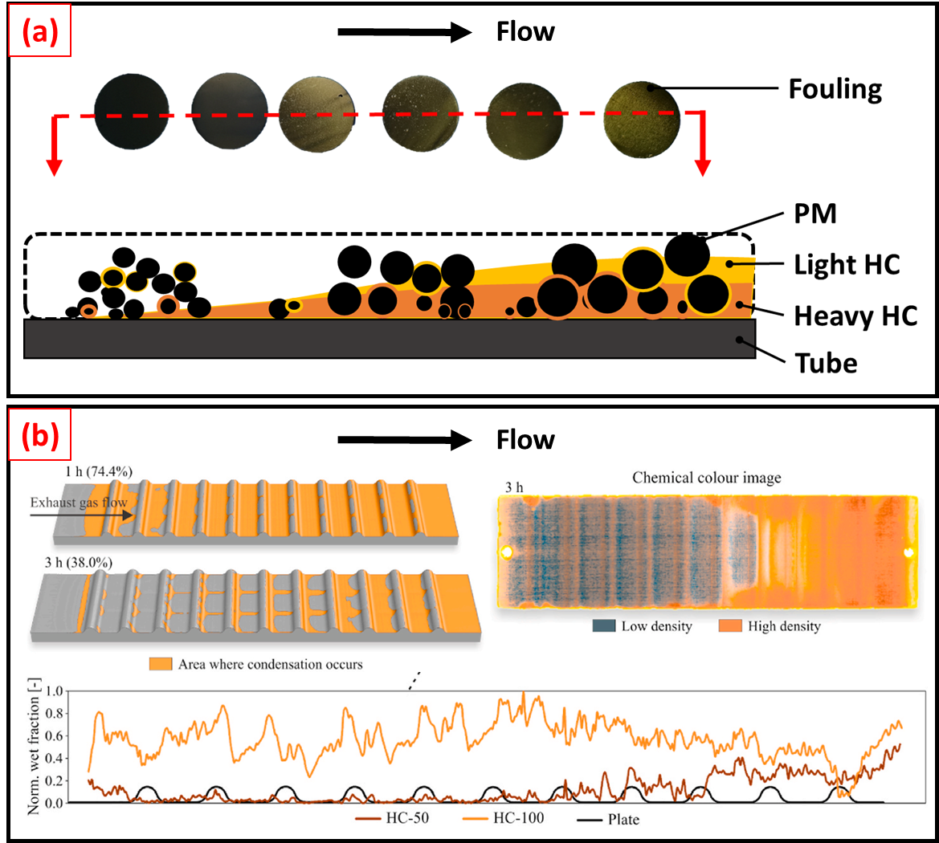
Figure S6. Fouling chemical colour distribution along the airflow direction. (a) Han et al. [10], (b) Vence et al. [12].
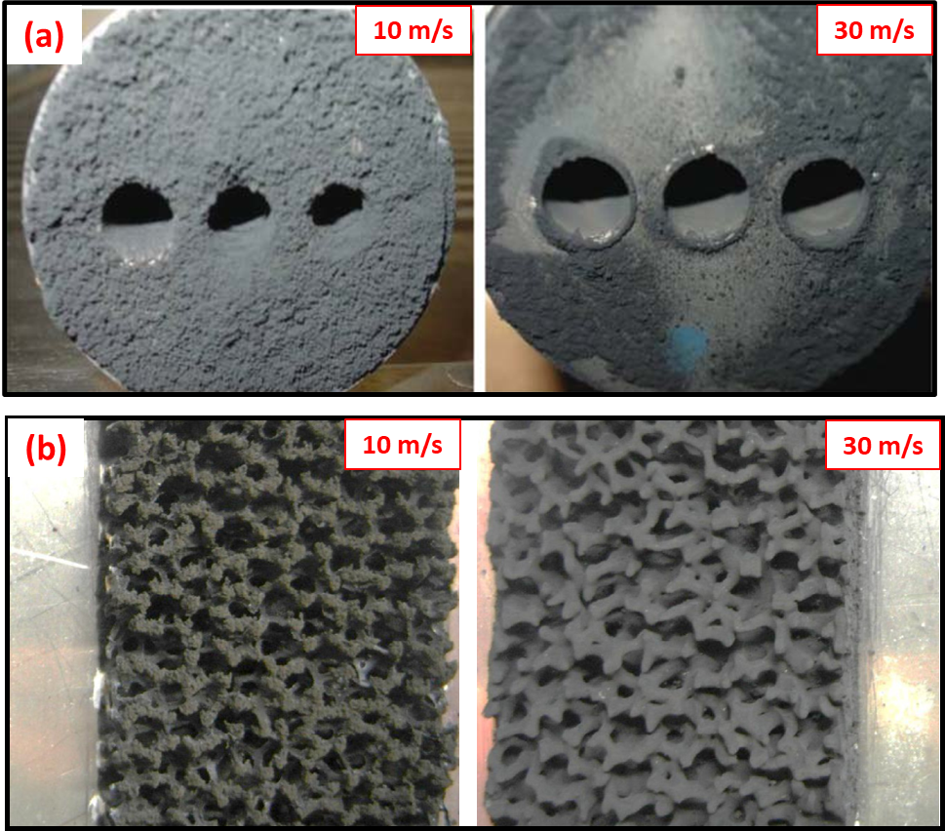
Figure S7. Effect of gas flow rate on fouling morphology. (a) Malayeri et al. [35], (b) Hooman and Malayeri [14].
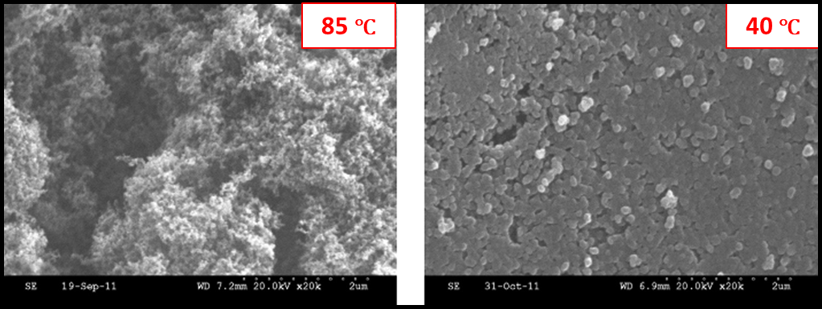
Figure S8. Effect of wall temperature on fouling morphology. Prabhakar and Boehman [37]
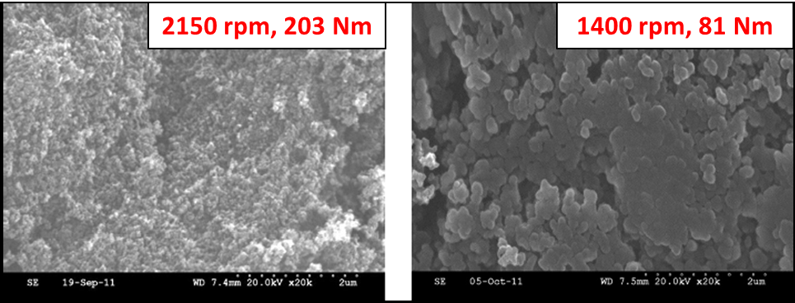
Figure S9. Effect of engine load on the fouling morphology [37]
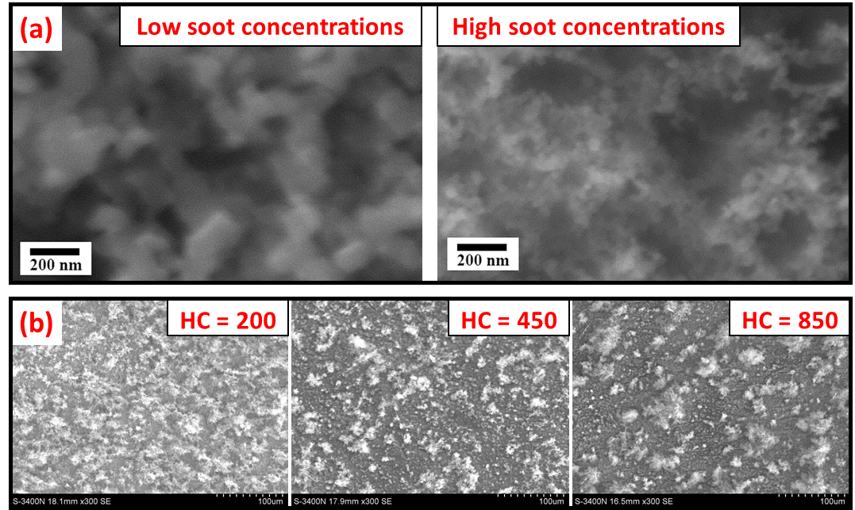
Figure S10. Effect of components of exhaust gas on the fouling morphology. (a) soot concentration [3], and (b) HC concentration [1].

Reference
[1] LI J, ZHANG X, WU H, et al. Effect of Hydrocarbon Concentration on Particulate Deposition and Microstructure of the Deposit in Exhaust Gas Recirculation Cooler [J]. International Journal of Automotive Technology, 2022, 23(3): 775-84.
[2] PAZ C, SUáREZ E, VENCE J, et al. Fouling evolution on ribbed surfaces under EGR dry soot conditions: Experimental measurements and 3D model validation [J]. International Journal of Thermal Sciences, 2020, 151.
[3] LANCE M J, MILLS Z G, SEYLAR J C, et al. The effect of engine operating conditions on exhaust gas recirculation cooler fouling [J]. International Journal of Heat and Mass Transfer, 2018, 126: 509-20.
[4] SHIBASAKI Y, SUGIMO A, GOTO N, et al. Evaluation of deposits in diesel EGR cooler (third report) Characterization of deposits layer [J]. Transactions of the Society of Automotive Engineers of Japan, 2010, 41: 1095-100.
[5] HOARD J, ABARHAM M, STYLES D, et al. Diesel EGR Cooler Fouling [J]. SAE International Journal of Engines, 2008, 1(1): 1234-50.
[6] PARK S, CHOI K, KIM H, et al. Influence of PM fouling on effectiveness of heat exchanges in a diesel engine with fin-type EGR coolers of different sizes [J]. Heat and Mass Transfer, 2010, 46(11-12): 1221-7.
[7] ABD-ELHADY M S, MALAYERI M R, MüLLER-STEINHAGEN H. Fouling Problems in Exhaust Gas Recirculation Coolers in the Automotive Industry [J]. Heat Transfer Engineering, 2011, 32(3-4): 248-57.
[8] ABARHAM M, CHAFEKAR T, HOARD J, et al. A Visualization Test Setup for Investigation of Water-Deposit Interaction in a Surrogate Rectangular Cooler Exposed to Diesel Exhaust Flow [J]. SAE Technical Paper, 2012.
[9] VENCE J, PAZ C, SUAREZ E, et al. Experimental evaluation of the effect of ozone treatment on the oxidation and removal of dry soot deposits of the exhaust gas recirculation system [J]. Heliyon, 2023, 9(7): e17861.
[10] HAN Z, YAO Y, TIAN W, et al. Effect of hydrocarbon condensation on fouling and heat exchange efficiency in EGR cooler [J]. International Journal of Thermal Sciences, 2023, 184: 12.
[11] YAO Y, HAN Z, TIAN W, et al. An original nondestructive sampling method to study the effect of gravity on the deposition of micron-sized large particles in exhaust gas recirculation (EGR) cooler fouling [J]. International Journal of Engine Research, 2023, 25(5): 928-39.
[12] VENCE J, PAZ C, SUáREZ E, et al. Analysis of the local growth and density evolution of soot deposits generated under hydrocarbon condensation: 3D simulation and detailed experimental validation [J]. Results in Engineering, 2023, 18: 101166.
[13] GALINDO J, DOLZ V, MONSALVE-SERRANO J, et al. Advantages of using a cooler bypass in the low-pressure exhaust gas recirculation line of a compression ignition diesel engine operating at cold conditions [J]. International Journal of Engine Research, 2020, 22(5): 1624-35.
[14] HOOMAN K, MALAYERI M R. Metal foams as gas coolers for exhaust gas recirculation systems subjected to particulate fouling [J]. Energy Conversion and Management, 2016, 117: 475-81.
[15] POURREZAEI M H, MALAYERI M R, HOOMAN K. Thermal performance and mechanisms of soot deposition in foam structured exhaust gas recirculation coolers [J]. International Journal of Thermal Sciences, 2019, 146.
[16] SHIKH ANUAR F, HOOMAN K, MALAYERI M R, et al. Experimental study of particulate fouling in partially filled channel with open-cell metal foam [J]. Experimental Thermal and Fluid Science, 2020, 110.
[17] FERNáNDEZ J V. Contribuciones al estudio de formación de depósitos hidrocarbonados en intercambiadores de calor del sistema EGR: desarrollo de modelo y validación experimental. [D]; University of vigo, 2020.
[18] STYLES D, CURTIS E, RAMESH N, et al. Factors Impacting EGR Cooler Fouling - Main Effects and Interactions [Z]. 16th Directions in Engine-Efficiency and Emission Research Conference (DEER). Detroit, MI. 2010: 1-25
[19] KUAN C-K, STYLES D, BIENIEK M, et al. An EGR Cooler Fouling Model: Experimental Correlation and Model Uses [J]. SAE International Journal of Engines, 2017, 10(2): 541-9.
[20] LANCE M J, SLUDER C S, LEWIS S, et al. Characterization of Field-Aged EGR Cooler Deposits [J]. SAE International Journal of Engines, 2010, 3(2): 126-36.
[21] LANCE M J, BILHEUX H, BILHEUX J-C, et al. Neutron Tomography of Exhaust Gas Recirculation Cooler Deposits [J]. SAE Technical Paper, 2014, 1.
[22] LANCE M J, STOREY J, SLUDER C S, et al. Microstructural Analysis of Deposits on Heavy-Duty EGR Coolers [J]. SAE Technical Paper, 2013, 2.
[23] BRAVO Y, LARROSA C, ARNAL C, et al. Effects of soot deposition on EGR coolers: Dependency on heat exchanger technology and engine conditions; proceedings of the Proceedings of International Conference on Heat Exchanger Fouling and Cleaning - 2013, F, 2013 [C].
[24] KAMP C J, BAGI S. Perspectives on Current and Future Requirements of Advanced Analytical and Characterization Methods in the Automotive Emissions Control Industry [J]. SAE International Journal of Sustainable Transportation, Energy, Environment, & Policy, 2021, 2(2): 141-60.
[25] LEPPERHOFF G, HOUBEN M. Mechanisms of deposit formation in internal combustion engines and heat exchangers [J]. SAE Technical Paper, 1993.
[26] JANG S-H, HWANG S-J, PARK S-K, et al. Effects of PM fouling on the heat exchange effectiveness of wave fin type EGR cooler for diesel engine use [J]. Heat and Mass Transfer, 2011, 48(6): 1081-7.
[27] WAREY A, BIKA A S, VASSALLO A, et al. Combination of Pre-EGR Cooler Oxidation Catalyst and Water Vapor Condensation to Mitigate Fouling [J]. SAE International Journal of Engines, 2014, 7(1): 21-31.
[28] PAZ C, CONDE M, VENCE J, et al. Experimental study of the effect of hydrocarbon condensation on the fouling deposits of exhaust gas recirculation coolers; proceedings of the Heat Exchanger Fouling and Cleaning – 2019, F, 2019 [C].
[29] TOMURO M, BHADRA K, HEBERT J, et al. The Effect of Exhaust Emission Conditions and Coolant Temperature on the Composition of Exhaust Gas Recirculation Cooler Deposits [J]. SAE Technical Paper, 2023.
[30] TOMURO M, HEBERT J, HOARD J, et al. The Influence of the Operating Duty Cycles on the Composition of Exhaust Gas Recirculation Cooler Deposits of Industrial Diesel Engines [J]. SAE Technical Paper, 2020, 2020-April.
[31] BRAVO Y, LUJAN J, TISEIRA A. Characterization of EGR cooler response for a range of engine conditions [J]. SAE International Journal of Engines, 2013, 6(1): 587-95.
[32] TANAKA K, HIROKI K, KIKUCHI T, et al. Investigation of Mechanism for Formation of EGR Deposit by in situ ATR-FTIR Spectrometer and SEM [J]. SAE International Journal of Engines, 2016, 9(4): 2242-9.
[33] TANAKA K, SAKAI T, FUJINO T, et al. Evaluation of Mechanism for EGR Deposit Formation Based on Spatially- and Time-Resolved Scanning-Electron-Microscope Observation [J]. SAE International Journal of Advances and Current Practices in Mobility, 2020, 3(1): 150-8.
[34] TENG H, BARNARD M. Physicochemical characteristics of soot deposits in EGR coolers [J]. SAE Technical Paper, 2010.
[35] MALAYERI M R, ZORNEK T, BALESTRINO S, et al. Deposition of Nanosized Soot Particles in Various EGR Coolers Under Thermophoretic and Isothermal Conditions [J]. Heat Transfer Engineering, 2013, 34(8-9): 665-73.
[36] PRABHAKAR B. Examination of EGR Cooler Fouling and Engine Efficiency Improvement in Compression Ignition Engines [D]; The Pennsylvania State University, 2013.
[37] PRABHAKAR B, BOEHMAN A L. Effect of Engine Operating Conditions and Coolant Temperature on the Physical and Chemical Properties of Deposits From an Automotive Exhaust Gas Recirculation Cooler [J]. Journal of Engineering for Gas Turbines and Power, 2013, 135(2).
[38] YOO K H, HOARD J, BOEHMAN A, et al. Experimental Studies of EGR Cooler Fouling on a GDI Engine [J]. SAE Technical Paper, 2016, 2016-April.
[39] TENG H, REGNER G. Particulate Fouling in EGR Coolers [J]. SAE International Journal of Commercial Vehicles, 2009, 2(2): 154-63.
[40] ABARHAM M, CHAFEKAR T, HOARD J W, et al. In-situ visualization of exhaust soot particle deposition and removal in channel flows [J]. Chemical Engineering Science, 2013, 87: 359-70.
[41] STOREY J M E, SLUDER C S, LANCE M J, et al. Exhaust Gas Recirculation Cooler Fouling in Diesel Applications: Fundamental Studies of Deposit Properties and Microstructure [J]. Heat Transfer Engineering, 2013, 34(8-9): 655-64.
[42] LI H, HOARD J, STYLES D, et al. Visual Study of In-Situ EGR Cooler Fouling Layer Evolution; proceedings of the ASME 2014 Internal Combustion Engine Division Fall Technical Conference, F, 2014 [C].
[43] RAZMAVAR A R, MALAYERI M R. Mitigation of Soot Deposition on Modified Surfaces of Exhaust Gas Recirculation Coolers [J]. Heat Transfer Engineering, 2019, 40(20): 1680-90.
[44] PAZ C, SUáREZ E, VENCE J, et al. Evolution of EGR cooler deposits under hydrocarbon condensation: Analysis of local thickness, roughness, and fouling layer density [J]. International Journal of Thermal Sciences, 2021, 161.
[45] VöLK P, WACHTMEISTER G, HöRNIG G, et al. Deposition mechanisms in exhaust heat exchangers [J]. MTZ worldwide, 2012, 73(9): 58-64.
[46] SALVI A, HOARD J, BIENIEK M, et al. Effect of volatiles on soot based deposit layers [J]. Journal of Engineering for Gas Turbines and Power, 2014, 136(11).
[47] SALVI A A, HOARD J, STYLES D, et al. In Situ Thermophysical Properties of an Evolving Carbon Nanoparticle Based Deposit Layer Utilizing a Novel Infrared and Optical Methodology [J]. Journal of Energy Resources Technology, 2016, 138(5): 052207.1-.7.
[48] HAN T, BOOTH A C, SONG S, et al. Review and a conceptual model of exhaust gas recirculation cooler fouling deposition and removal mechanism; proceedings of the Proceedings of International Conference on Heat Exchanger Fouling and Cleaning - 2015, F, 2015 [C]. Heat Exchanger Fouling and Cleaning.
[49] WAREY A, BIKA A S, LONG D, et al. Influence of water vapor condensation on exhaust gas recirculation cooler fouling [J]. International Journal of Heat and Mass Transfer, 2013, 65: 807-16.
[50] RAZMAVAR A, MALAYERI M R. Thermal performance of a rectangular exhaust gas recirculation cooler subject to hydrocarbon and water vapor condensation [J]. International Journal of Thermal Sciences, 2019, 143: 1-13.
[51] AL-JANABI A, MALAYERI M R. Turbulence induced structures in Exhaust Gas Recirculation coolers to enhance thermal performance [J]. International Journal of Thermal Sciences, 2017, 112: 118-28.
[52] LI J. Study on exhaust gas recirculation cooler fouling in diesel [D]; Xihua University, 2021.
[53] ABD-ELHADY M S, ZORNEK T, MALAYERI M R, et al. Influence of gas velocity on particulate fouling of exhaust gas recirculation coolers [J]. International Journal of Heat and Mass Transfer, 2011, 54(4): 838-46.
[54] USUI S, ITO K, KATO K. The Effect of Semi-Circular Micro Riblets on the Deposition of Diesel Exhaust Particulate [J]. SAE Technical Paper, 2004.
[55] SLUDER C S, STOREY J, LANCE M J, et al. Removal of EGR cooler deposit material by flow-induced shear [J]. SAE International Journal of Engines, 2013, 6(2): 999-1008.
[56] ARNAL C, BRAVO Y, LARROSA C, et al. Characterization of Different Types of Diesel (EGR Cooler) Soot Samples [J]. SAE International Journal of Engines, 2015, 8(4): 1804-14.
[57] ARNAL C, BRAVO Y, LARROSA C, et al. Correlation between Real Diesel Fouled-EGRc Soot Samples and Soot Surrogates: Reactivity with NO and O2 and Chemical-Physical Characterization [J]. SAE Technical Paper, 2018.
[58] BRAVO Y, LARROSA C, ARNAL C, et al. Examination of Soot Deposition on EGR Coolers [R], 2015.
[59] YUAN S, ZHAO C, CAI X, et al. Bubble evolution and transport in PEM water electrolysis: Mechanism, impact, and management [J]. Progress in Energy and Combustion Science, 2023, 96.

